PECUNIA BANK MANAGEMENT
Epic & Stories
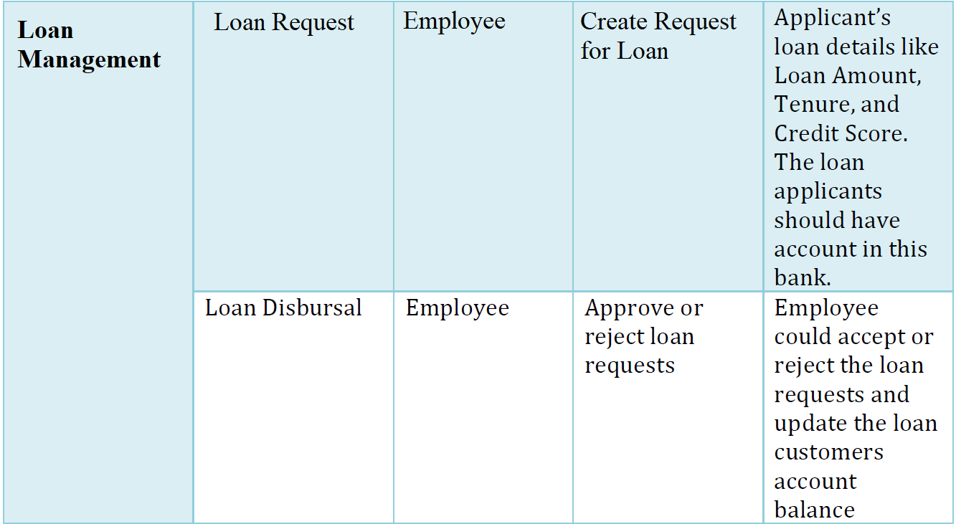

Use Case Diagram
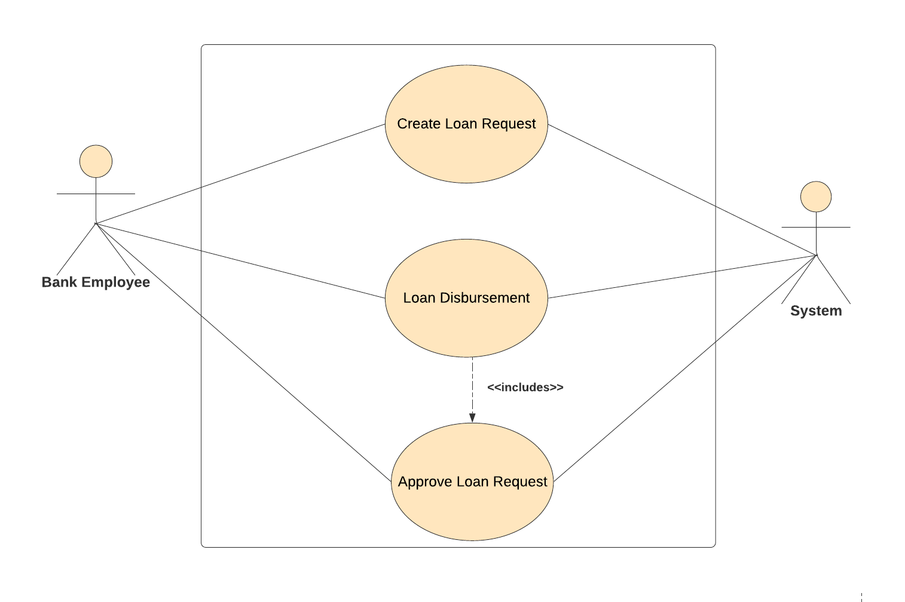
Class Diagram
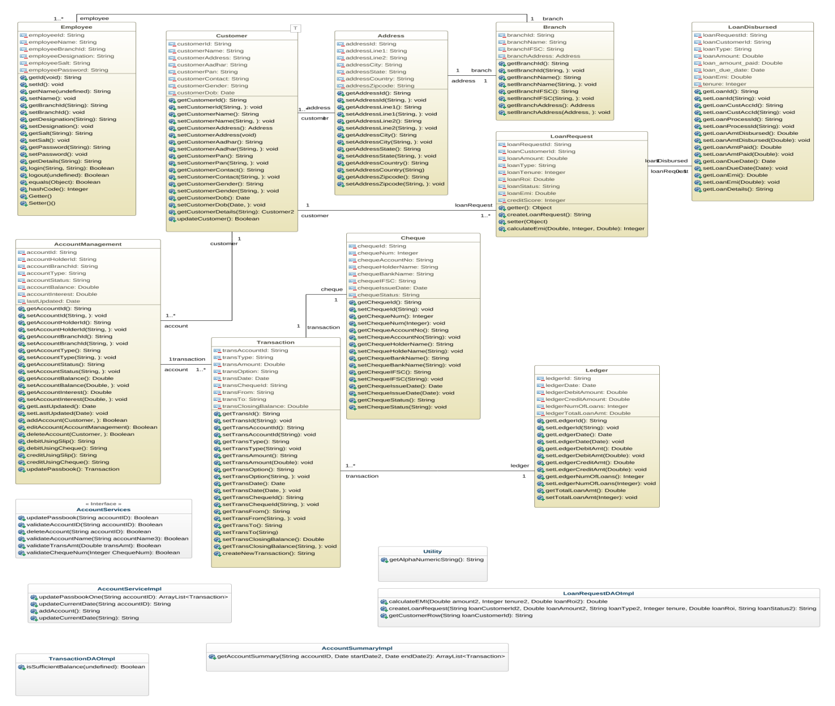

ER Diagram
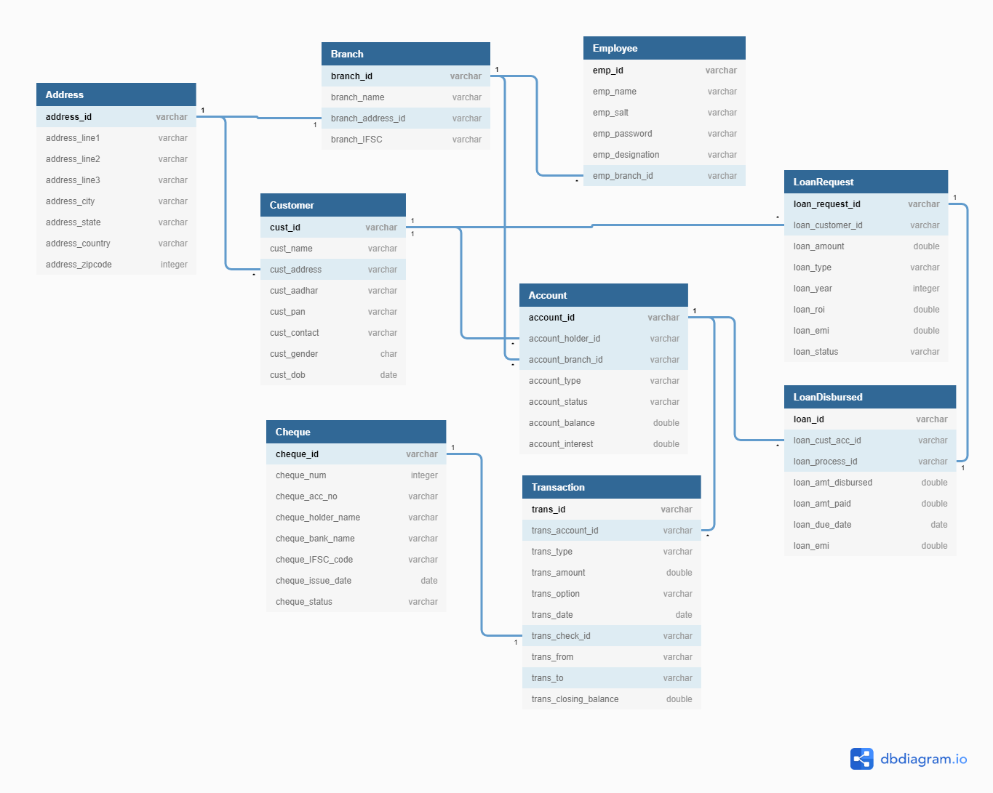
Sequence Diagram For Loan Approval
Sequence Diagram For Retrieving All Loan Requests

Sequence Diagram For Retrieving Loan Disbursed Data
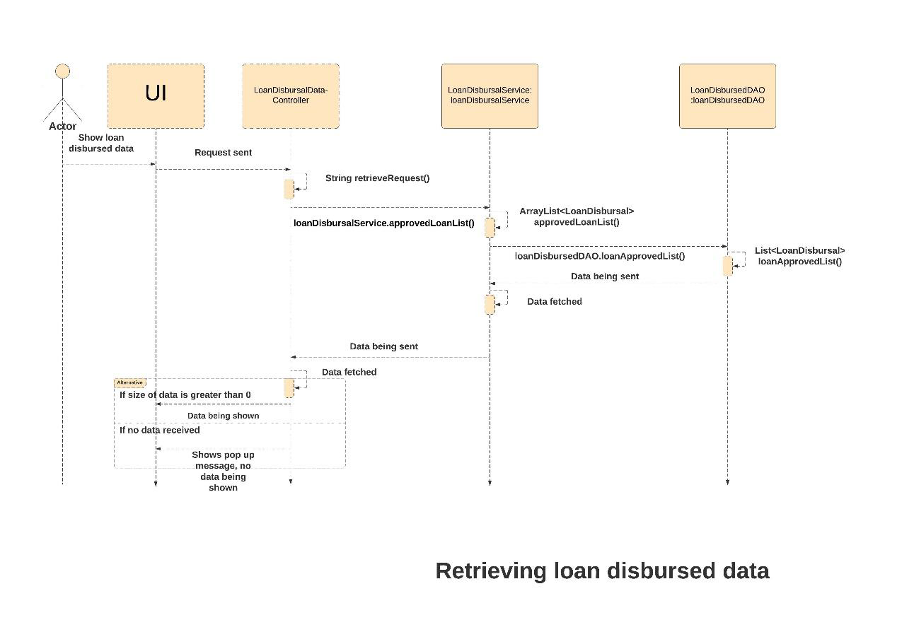
Sequence Diagram For Update Account Balance

